Ranjeet Parida
Phone_No:0671-2358982, Mobile: 09853855544 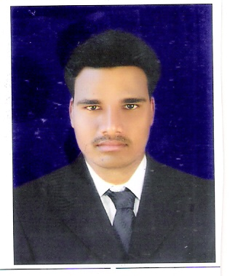
Email: ranjeet3km@gmail.com

Seeking assignments in Sales & Marketing/Business Development with an organisation of repute.

Career Abridgement
- A visionary with verifiable success of over 3 years and 5 months in achieving revenue, profit and business growth objectives in diverse industries like that of Banking and Telecom
- Presently employed with Kotak Mahindra Bank Ltd. as Asst. Manager in Business Banking Group.
- An effective communicator with excellent relationship building & interpersonal skills. Strong analytical, problem solving & organizational abilities. Possess a flexible & detail oriented attitude

Areas of Expertise

Sales & Marketing
- Developing marketing strategies to build customer preference and drive volumes.
- Conducting competitor analysis by keeping abreast of market trends and competitor moves to achieve market share metrics

Business Development/Key Account Management
- Identifying prospective clients, generating business from existing accounts & achieving targets.
- Evolving market segmentation & penetration strategies to achieve targets.

Channel / Distribution Management
- Identifying & networking with channel partners, resulting in market penetration & reach.
- Evaluating performance & monitoring their sales and marketing activities.
- Handling logistic & supply chain function ensuring availability of stock at all the selling points.

Team Management
- Leading, mentoring & monitoring the performance of team members to ensure efficiency in process operations and meeting of individual & group targets.
- Creating and sustaining a dynamic environment that fosters development opportunities and motivates high performance amongst Team members.

Organisational Facets

Jan’13- Till date KOTAK MAHINDRA BANK Ltd. Asst. Manager

Role

Looking after Current ,Saving and demat Accounts as well as LI, FD,RD, MFs and asset management.

Dec ’09 – Dec’12 HDFC Bank Ltd. Team Leader (CA,SA)

Role

Handling sales of Banking Products i.e. Life Insurances, Fixed Deposits, CA, SA etc.

March07 – Nov’09 ICICI Bank Ltd. Business Devlopment Executive

Role
Handling sales of banking products in banking group.

Notable Accolades

- Interfaced with Small Enterprise customers in Orissa

- Successfully accomplished operations related to Liability products (All sorts of current accounts,business card, FDs, helping cross sell division for Mutual Fund and insurance(Life & general both)

Mar’06 – Feb’07 M.K Consultant DCID(Data Collection & Information Discremination)
For ICICI Bank Ltd (Liability-- division)

Role

Tracing out potential customers in the service area

Generating Lead for Current a/c

Collecting all the details of the customer

Notable Accolades

- Took steps in solving emergency issues which required quick follow-up for all leads

- Displayed skills in assuring adherence to quality of leads

Jan‘03 – Feb‘06 Airtel Marketing Executive

Role

Selling STD Lines ,& Pre-paid voucher to customers in Orissa

Notable Accolades

- Led a team of 8 people

- Highest Performer consecutively for 2 months in entire Orissa

Academic Credentials

2009 MBA with specialization in Finance from Sikkim Manipal University
2002 Bachelor of ARTs from UTKAL University
1998 Higher Secondary Education from C.S.H.E, Orissa
1995 HSCF from B.S.E, Orissa
Software Proficiency
Well versed in P.C. Operation Windows 98, DCA, MS-OFFICE.
Achievements
Best championship award at “Chalo Mumbai Contest” in July-Aug’07

Personal Vitae

Father’s name : Mr Laxman Parida

Date of birth : 28th Aug 1980

Address : AT/PO-Bhatapara, VIA-Bahugram, Dist-Cuttack, Pin-754200,Orissa

Ranjeet Parida

